**BBQ Corner**

Business proposal

|  |  |  |
| --- | --- | --- |
| Name | Task | E-mail |
| LI Zhi | Summary | [zhi.li@johnabbottcollege.net](mailto:zhi.li@johnabbottcollege.net) |
| XIE Linlin | Sitemap | [linlin.xie@johnabbottcollege.net](mailto:linlin.xie@johnabbottcollege.net) |
| KIM Sang Kyu | Trello | [sang.kim@johnabbottcollege.net](mailto:sang.kim@johnabbottcollege.net) |
| TANG Shixin | Project Estimation | [shixin.Tang@johnabbottcollege.net](mailto:shixin.Tang@johnabbottcollege.net) |
| CAO Lisi | Final Report | [lisi.cao@johnabbottcollege.net](mailto:lisi.cao@johnabbottcollege.net) |

Table of Contents

Executive Summary of User Requirements 2

Sitemap 3

Project Management Tool 4

Project Estimation 6

# Executive Summary of User Requirements

**Improvements for the Restaurant Website**

1. Enhance Menu Presentation

1.1 Showcase vivid images of menu items, offering customers a more tangible understanding of the dishes.

1.2 Provide detailed descriptions of ingredients and recipes for each dish, allowing customers to appreciate our commitment to quality and our cooking process.

1.3 Highlight specialty dishes prominently, enabling customers to identify our signature offerings at a glance.

2. Develop a Homepage with Business Hours and Location Information

Include the restaurant's opening hours and physical location prominently on the homepage, facilitating customer inquiries and dining planning.

3. Design an 'About Us' Page Incorporating Background, Chefs, and Management Team Information

Tell our story by giving insight into our history, introducing our experienced chefs, and showcasing the key members of our management team.

**The proposed completion date for this project is 6th June.**

# Sitemap

Our website is structured to be as intuitive and straightforward as possible, offering users a seamless navigation experience. Here is a brief overview of our sitemap: sitemap


**Home Page:** This is the first page that users will encounter when visiting our website. It will display essential information about our restaurant including operating hours and location.

**Menu:** On the Menu page, users can browse detailed information about all the dishes we offer, including ingredients, cooking methods, and corresponding images. Through this page, users will gain a better idea of the variety and specialty of our cuisine.

**Specialty Menu:** Our Specialty Menu page highlights the unique dishes that our restaurant is renowned for. These are dishes our culinary team has put much thought and effort into creating. For customers looking for a unique dining experience, this page will be their go-to.

**About Us:** This page provides a comprehensive introduction to our restaurant's history and team. By browsing this page, users can delve into the story of our restaurant.

Our goal is to ensure that every user visiting our website can conveniently find the information they need, enhancing their online experience while building anticipation for their dining experience at our restaurant.

# Project Management Tool

**Step One: Role Distribution for the Project Meeting**

Our project team is structured as follows:

* Product Owner: Zhi Li
* Scrum Master: Sang Kyu Kim
* Scrum Team: Shixin Tang, Lisi Cao, Linlin Xie

**Step Two: Daily Scrum**

Our Daily Scrum will incorporate the following activities:

* Backlog Check: We will review the client interview and refine our to-do list, ensuring we stay aligned with the client's requirements.
* Schedule Review: We will continually monitor our timeline to ensure that we are on track to meet the due date.
* Workflow Discussion: We will discuss production progress and workflow efficiency, identifying any obstacles and potential solutions.

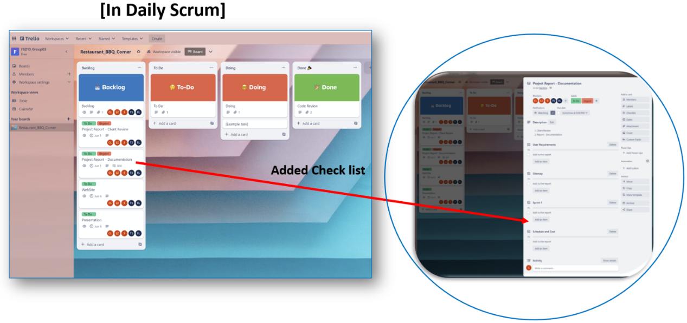

**Step Three: Tasks in Progress**

As we work on our tasks, we will continuously update our progress, providing visibility into our work's status and identifying any potential roadblocks early.

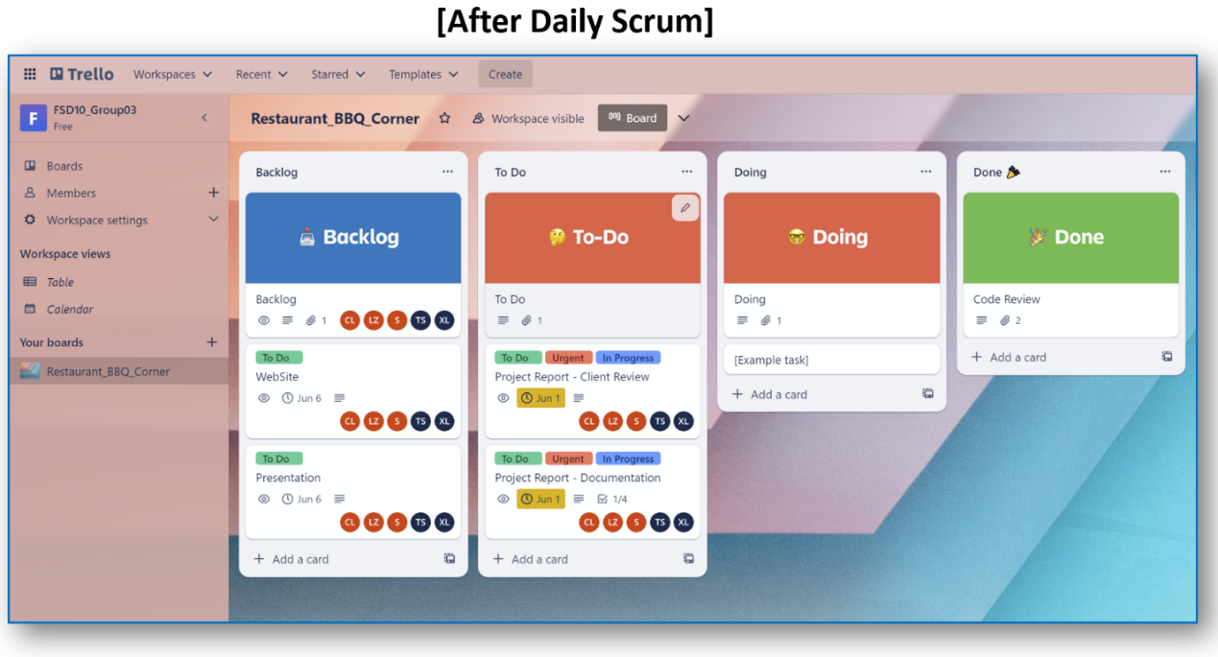

**Project Management Tool (Trello)**

We will use Trello as our project management tool:

* Trello will allow us to track the progress of each task effectively, ensuring transparency within the team and helping us stay on top of our work. By moving tasks from "To Do" to "Doing" to "Done," we can visualize our workflow and balance our workload efficiently.

# Project Estimation

**Schedule**:

|  |  |  |
| --- | --- | --- |
| **Project** | **Start Date** | **End Date** |
| **BBQ Corner Restaurant** | May 31, 2023 | June 6, 2023 |

This project will start on **May 31, 2023,** and end on **June 6, 2023.**

|  |  |  |
| --- | --- | --- |
| **Task** | **Start Date** | **Days** |
| **Client Interview** | May 31, 2023 | 1 |
| **Project Report** | June 1, 2023 | 1 |
| **Website Building** | June 2, 2023 | 1 |
| **Presentation Slides** | June 5, 2023 | 1 |
| **Team Presentation & Evaluation** | June 6, 2023 | 1 |

This table showcases the project tasks, start dates, and durations for the BBQ Corner Restaurant project.

**Cost Breakdown:**

|  |  |  |  |  |  |  |  |
| --- | --- | --- | --- | --- | --- | --- | --- |
| **Task (hours)** | **Tang, Shixin** | **Cao, Lisi** | **Li, Zhi** | **Sang, Kim** | **Xie Linlin** | **Total** | **Cost** |
| **Client Interview** | 2 | 2 | 2 | 2 | 2 | 10 | $400.00 |
| **Project Report** | 4 | 4 | 4 | 4 | 4 | 20 | $800.00 |
| **Development** | 8 | 8 | 8 | 8 | 8 | 40 | $1,600.00 |
| **Presentation** | 5 | 5 | 5 | 5 | 5 | 25 | $1,000.00 |
| **Total** | 19 | 19 | 19 | 19 | 19 | 95 | $3,800.00 |
|  |  |  |  |  |  |  |  |
| **Hour Rate** | **$40** | | | | | | |
| **Total Cost** | **$3,800** | | | | | | |

This table displays the task-wise breakdown of costs for the BBQ Corner Restaurant project.